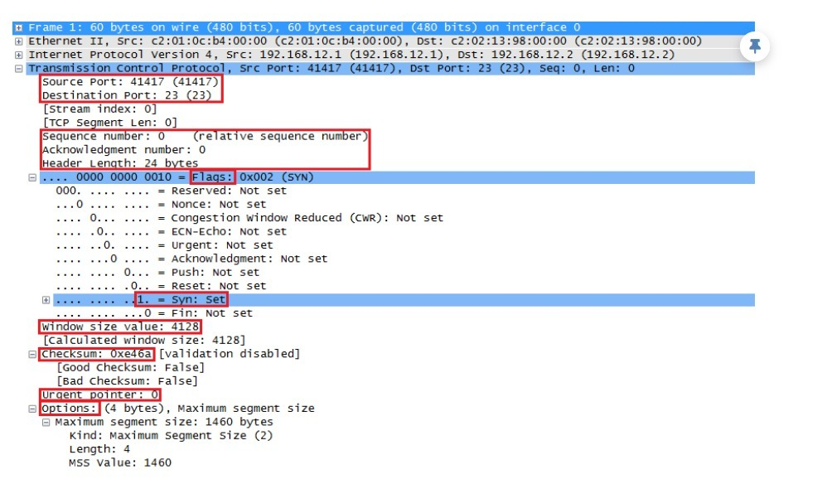<https://networklessons.com/cisco/ccie-routing-switching-written/tcp-header>

1.a. Design a program to demonstrate how IP header could be read and interpreted using C/python programming language. b. Compare and contrast MAC addressing and IP addressing schemes  
2.a. Exhibit how OSPF routing protocol works with complete internal operations using C/ python programming language. b. Analyse the word “Network protocols” using keywords such as What, Why & How  
3.a. Show how RIP protocol manages a router with complete internal operations using C/ python programming language. b. Compare and contrast Network Congestion and Network Collisions.  
4.a. Demonstrate how RARP protocol works with complete internal operations using C/ python programming language. b. Compare and contrast Wired Networks and Wireless Networks.  
5.a. Exhibit how TCP header could be read and interpreted using C/ python programming language. b. Analyse the word “Network Topologies” using keywords such as What, Why & How

<http://campuscoke.blogspot.com/2015/01/tcp-header-format-in-c.html?m=1>